Kid’s Day Exploration Tent Booth
Registration Form:
Return by:
Group/Organization Name: ___________________________________________
Contact Person: _____________________________________________________
Address: ___________________________________________________________
City: ____________________ Zip Code: ____________________________
Email Address: ______________________________________________________
Telephone Number: __________________________________________________
Day of the Event Telephone Number: ____________________________________
My Organization would like to request a (check one)
Tent Space (includes 6’ table & 2 chairs- no electricity)
Outdoor Space-Please describe what you need
Bringing Vehicle
Are you willing to be a passport stop and if so, what question would you like the kids to answer on their passport while at your booth?

Brief description of items to be displayed, handed out, acted out or set up (please do not sell any items):
Please describe any needs you have:
In using this space for the 2022 Kid’s Day Exploration Tent, I amfully aware that the MSU Extension, Gratiot County Fair for Youth, and/or Gratiot County assumes no responsibility.
Signature of contact person: ______________________________ Date: ________
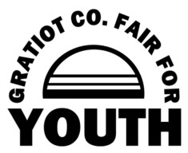
Return this agreement to
Gratiot County Fair For Youth,
P.O. Box 1024 701 S. Lincoln Ave., Alma MI, 4880
Telephone: 989-466-5071 info@gcffy.org or interngcffy@gmail.com

